**Les régions de France**

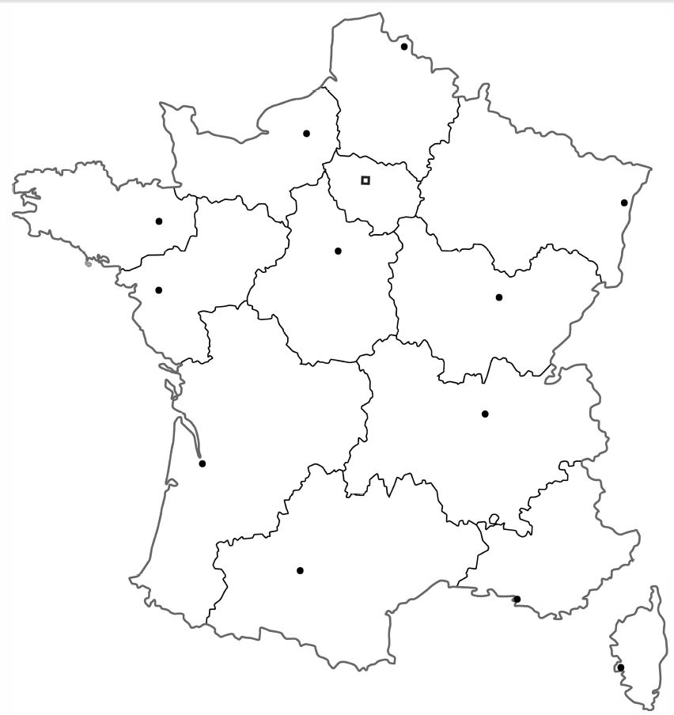

**10**

**8**

**5**

**9**

**6**

**11**

**4**

**12**

|  |  |  |  |  |  |
| --- | --- | --- | --- | --- | --- |
| 1 |  | 6 |  | 11 |  |
| 2 |  | 7 |  | 12 |  |
| 3 |  | 8 |  | 13 |  |
| 4 |  | 9 |  |  |  |
| 5 |  | 10 |  |  |  |

**2**

**3**

**7**

**13**

**1**